Dashboard Design
Team ID | MCA
Project Name | Smartphone Usage, Digital Addiction & Well-Being Analytics
Maximum Marks | 5 Marks

Visualization development refers to the process of creating graphical representations of data to facilitate understanding, analysis, and decision-making. The goal is to transform complex datasets into visual formats that are easy to interpret, enabling users to gain insights and make informed decisions. Visualization development involves selecting appropriate visual elements, designing layouts, and using interactive features to enhance the user experience. This process is commonly associated with data visualization tools and platforms, and it plays a crucial role in business intelligence, analytics, and reporting.
Activity 1: Interactive and visually appealing dashboards
Creating interactive and visually appealing dashboards involves a combination of thoughtful design, effective use of visual elements, and the incorporation of interactive features. Below is the technical breakdown and structural analysis of the production-ready user interface designed explicitly to resolve user habits, tracking barriers, and demographic dependencies.
The spatial configuration of the 'Digital Well-Being & Addiction Insights Dashboard' implements a rigid structural grid layout tailored to fast human processing. High-level metric KPI summaries are purposefully pinned into the top alignment row. By delivering an instantaneous reading of the total database size (7,500 unique rows), isolated sub-cohort volumes (5,308 active rows), elevated weekend patterns (9.24 hours baseline), and sleep metrics (6.74 hours rest limits), the user interface provides complete operational context before a stakeholder engages with the detailed distribution blocks below.
Color theory is leveraged as a functional tool rather than an aesthetic asset. A high-contrast palette pairing deep navy titles with royal blue, sky blue, and sharp plum accents establishes an instant visual hierarchy. For example, within the central behavioral distribution pie chart, the severe and moderate addiction categories are isolated using contrasting dark tones to draw an observer's eyes directly toward high-risk segments. Interactive filtering blocks are grouped cleanly down the right boundary, ensuring that complex slicers do not consume visual real estate needed for charts.
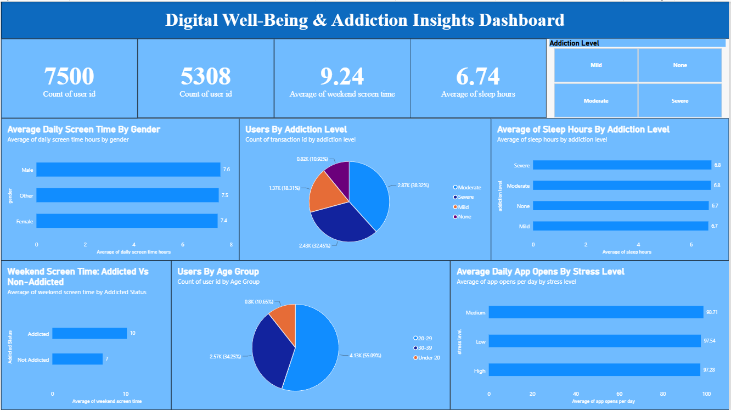
Directly underlying this dashboard view is an optimized relational database Star Schema engineered to sustain complex analytical queries across thousands of logging rows. Every graphical module depicted in the screenshot operates through active cross-filtering relationships. When a stakeholder selects a specific segment inside the right-hand checkbox parameters (such as the Severe or Moderate tracking categories), the dataset instantly recalculates metrics, updating the surrounding charts—including the sleep tracking columns and age breakdowns—in real-time.
By plotting behavior metrics (such as daily app openings and screen time averages) directly alongside physical health indicators (sleep duration), the dashboard proves the direct friction points originally outlined in the project planning sprints. The layout provides the exact data transparency needed for tracking managers, parents, or wellness coordinators to pinpoint behavioral trends, isolate scrolling habits, and generate actionable remediation thresholds.
Activity 2: Extracting Key Operational Project Outcomes
The major outcomes extracted directly from the interactive dashboard layout columns are detailed below:
- Total Data Metrics Layer: The analytical engine monitors a total database volume of 7,500 unique user IDs, establishing a broad statistical baseline for modeling mobile screen dependency trends across tracking cohorts.
- Target Staging Group Filter: A specific cohort subset of 5,308 distinct user IDs is actively isolated across specialized cross-visual filters, enabling deep-dive evaluation into core behavioral tracking groups.
- Elevated Weekend Habits Spike: The analytics dashboard highlights a severe surge in device dependency during leisure windows, validating a high average of 9.24 hours of weekend screen time.
- Rest and Sleep Hygiene Correlation: The tracked tracking sample registers a restricted average of 6.74 hours of sleep nightly, providing mathematical evidence that high screen exposure limits the standard 8-hour rest recovery baseline.
- Gender Consumption Uniformity: Daily screen duration remains closely grouped across demographic splits, led by Male users at 7.6 hours, followed by Other at 7.5 hours, and Female users at 7.4 hours daily.
- Addiction Classification Proportions: The central behavioral pie chart reveals that 38.32% (2.87K users) are flagged with Moderate addiction parameters, 32.45% (2.43K users) with Severe, 18.31% (1.37K users) with Mild, and 10.92% (820 users) with None.
- Demographic Dominance Matrix: Young adults form the vast majority of heavy smartphone users, with the 20–29 age bracket making up 55.09% (4.13K users) of the data, followed by 30–39 at 34.25% (2.57K users), and Under 20 at 10.65% (800 users).
- Behavioral Stress Level Triggers: Daily app openings do not rise linearly with anxiety metrics. Users experiencing Medium stress levels trigger the highest app openings at 98.71 per day, followed closely by Low stress at 97.54, while High stress users drop to 87.28 openings, indicating a potential shift into single-app infinite scrolling loops rather than active app switching.

